Our first example of machine learning is making a genetic algorithm; the goal is to develop a little coloured person game that will breed new people colours based on your choice of the “fittest.” Let’s start by taking a look at the difference artificial intelligence and machine learning:

Artificial Intelligence encompasses a whole domain of intelligent and behavioural algorithms. You can see the types of things covered here. Machine Learning is a small area within that domain.

AI Domains

What is Machine Learning (ML)?

ML is a system that has the ability to automatically learn from experience and adapt in real time rather than being explicitly programmed to do so. Here you can see character attempting to learn to walk:



Source: https://rednuht.org/genetic_walkers/

We will talk more about him a little later, but for now it is important to note that it requires quite sophisticated mathematics and statistics. For our work, it is worth learning about quaternions. This is something you should define in your own words, so briefly stated:

Quaternions are effectively extensions of the complex numbers. Instead of just the square root of -1, there are three, called i, j, and k. Quaternions, therefore, consist of a real-part and three imaginary parts. When you multiply them out (*i.e.* i*j*k) the result is equal to -1. These rules are sufficient to derive the formula for quaternion multiplication, that should be noted, is non-commutative (*i.e.* there exist *a* and *b* in such that a*b and b*a are different). The *conjugate* of a quaternion has all the imaginary parts negated.

**More complex details that you can safely ignore… for now.**

The set of unit quaternions is a double cover for the set of 3D rotations, meaning for every rotation in 3D space, there are exactly 2 corresponding quaternions. Used in this way, the operation of quaternion multiplication is equivalent to the operation of composition of rotations.

Quaternions are preferable to Euler/Tait-Byran angles because they do not possess any singularities. With Euler angles, you sometimes get a situation where a continuous rotation of the object would cause an abrupt jump in one of the parameters. This situation is called gimbal lock, and it means more complex code is required to implement Euler angles properly. Quaternions are also much easier to interpolate and compose than Euler angles (Naive linear interpolation/composition of individual Euler angles will *not* work).

Quaternions are preferred over rotation matrices because they are much smaller, and composition is quicker. However, quaternions are slower at transforming vertices so they should be converted to a rotation matrix before passing to the vertex shader.

What Are Genetic Algorithms?

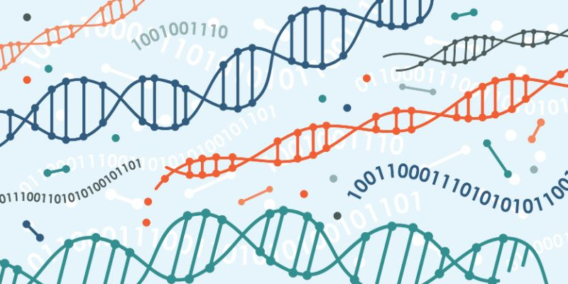

Genetic algorithms (GAs) are a type of computational optimisation technique inspired by the principles of natural selection and genetics. Simply put, we can call Gas “computational evolution.” They are used to solve complex problems by mimicking the process of evolution to improve a population of potential solutions iteratively.

As we will see in this Unity project, at the core of a genetic algorithm is the concept of a population, representing a collection of potential solutions to the problem at hand. Individuals within the population correspond to a particular solution, and a set of parameters called genes defines its characteristics. These genes encode the properties or features of the solution. While these features can be represented as binary strings (and often are), we will be working with real-valued numbers, and other data types as we code for a coloured person bias in a population.

The genetic algorithm begins with an initial population of individuals that we will generate randomly. We then go through a series of iterations, known as generations or epochs, in which the individuals undergo operations such as selection, crossover, and mutation. These operations mimic the processes of natural selection, reproduction, and genetic variation observed in biological evolution.

During the selection phase, individuals from the current population are evaluated based on a fitness function­—in our case, colour. The individuals with higher fitness values are more likely to be selected for further processing, simulating the survival of the fittest. Initially, these fitness values will depend upon the user’s bias as you select a colour from a set population.

**Genetic Algorithms Simply Put (Evolutionary Computing)**

1. A population of agents is programmed to randomly act.
2. The population acts.
3. The actions of individuals are assessed according to some fitness criteria and the Untermenschen are culled.
4. The remaining individuals breed to create a new population.

Technical Details in GAs

**Recombination**

Crossover, or recombination, is a genetic operator where two selected individuals exchange genetic information to create offspring. This operation is analogous to sexual reproduction, where genetic material from both parents is combined to produce genetically diverse offspring.

**Mutation**

Mutation introduces small random changes in the genetic information of selected individuals. This operation helps maintain genetic diversity within the population, allowing exploration of different regions of the solution space.

**Generations**

After the genetic operators are applied, a new population is created, replacing the previous generation. This process is repeated for a fixed number of generations or until a termination condition is met, such as reaching a desired fitness level or exceeding a specified number of iterations.

Over the course of multiple generations, genetic algorithms explore the solution space, favouring solutions with higher fitness values. The algorithm can converge towards an optimal or near-optimal solution by iteratively applying selection, crossover, and mutation.

Genetic algorithms have been successfully applied to various optimisation problems, including parameter tuning, scheduling, routing, and machine learning. Their ability to explore large solution spaces and find globally optimal or near-optimal solutions makes them particularly useful in cases where traditional optimization methods may struggle due to complex or non-linear problem landscapes.

Let’s take a closer look at how this works in practice:



agent

Chromosome

Agent

DNA

Each agent has a string of DNA made up of chromosomes. Since we are programming our agent, we refer to this as an array with indices. We can place anything in the DNA array that makes sense with respect to its purpose. It could be a Boolean, int, float, *etc.* Let’s say this agent is in a maze-like setting.

Ceiling

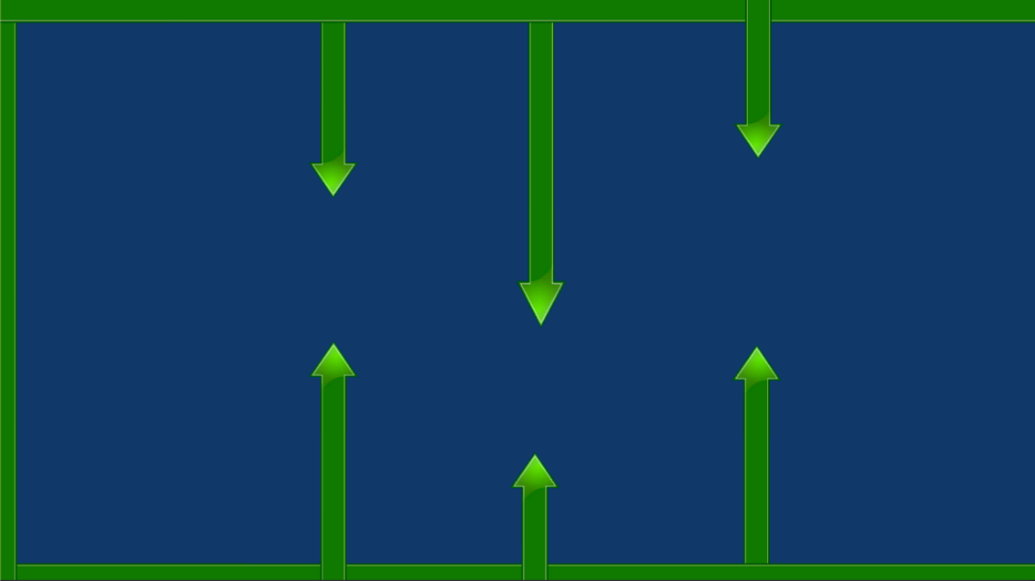

Bottom Arrow

Top Arrow

**Algorithm Simplified**

if (see ceiling)

move down

else if (see floor)

move up

else if (see top arrow)

move down

else if (see bottom arrow)

move up

Velocity



Floor

To simplify things, we have given this agent an automatic forward velocity that will push it forward. To get through this maze, the agent is going to have to move up and down. So how does it know when to do that? The agent needs some rules to follow! So we might hardcode these rules using ray-casts so when the rule it met, each of these “if conditions” becomes a chromosome in the DNA.

**Algorithm Simplified**

if (see ceiling)

move DNA[0]

else if (see floor)

move DNA[1]

else if (see top arrow)

move DNA[2]

else if (see bottom arrow)

move DNA[3]

else

move DNA[4]

Chromosome

Bottom

Nothing

Floor

Ceiling

Top

DNA

Now we can repeat the example with a population!

Nothing

Bottom

Top

Floor

Ceiling

DNA

Chromosome

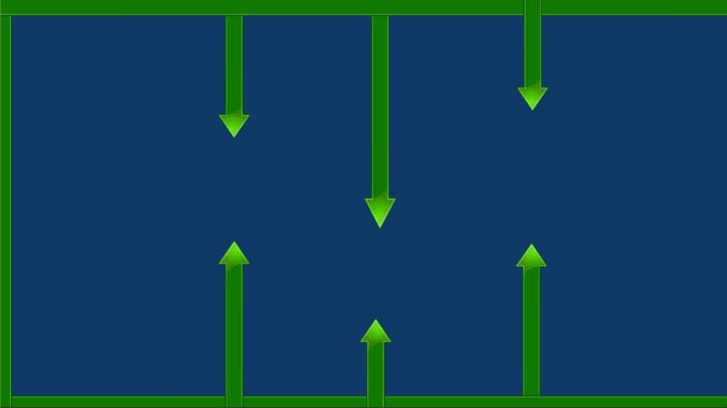

-0.2

0.1

-0.9

0.9

0.1

-0.2

0.1

0.9

-0.3

0.0

-0.5

0.2

0.3

-0.9

0.1



A whole population of our agents are set with random values of the chromosomes. Therefore, they can move in any direction at all when they detect any of the walls. Some lucky few will have chromosomes that help them move further across the screen. The further they get, the better their set of chromosomes. These are declared as the fittest, and the ones that did poorly are discarded. The remaining have their DNA combined to produce offspring. And the cycle iterates again. Notice we do not add the DNA values together but rather take some of the chromosomes from one parent and the rest from the other. This is the recombination.

So what about our character above learning to walk? After 3238 generations:



Now with some learning behind us, let us begin with our Unity project. First, create a new 2D project:

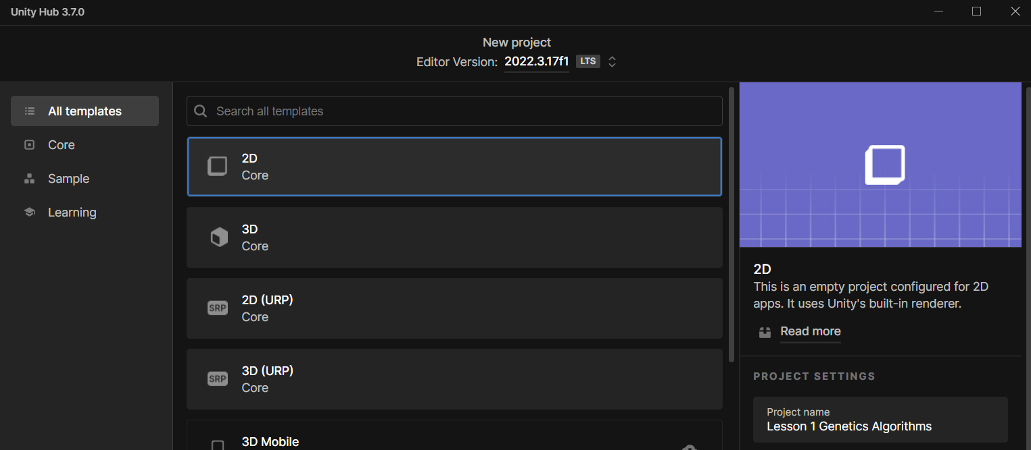

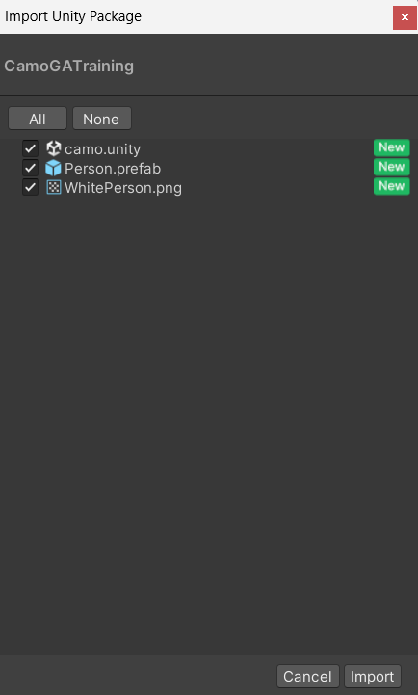Inside a folder named CamoGATraining (your teacher will give you access to this), with your Unity project open, open the file named CamoGATraining.unitypackage—this will bring up an import menu you can see to the left. Click import. From here, drag the file named “camo” into the scene (you can remove the default scene by right-clicking on the scene in the Hierarchy View > Remove Scene.

Also contained in the assets are the prefab Person (prefabs are generally indicated by a blue box), and a sprite named WhitePerson. The prefab Person contains a transform, a Sprite renderer, and a box collider (viewable from the Inspector panel).

The 2D Box Collider will allow us to click on the person prefabs (*i.e.* agents) triggering a destroy function. We will begin from here by creating a new C-sharp file. Right-click in Assets > Create > C# Script. Name the script DNA.

Before opening the script, drag and drop it onto the person prefab and make sure it is attached. Then you can double click on the script to open it in Visual Studio.

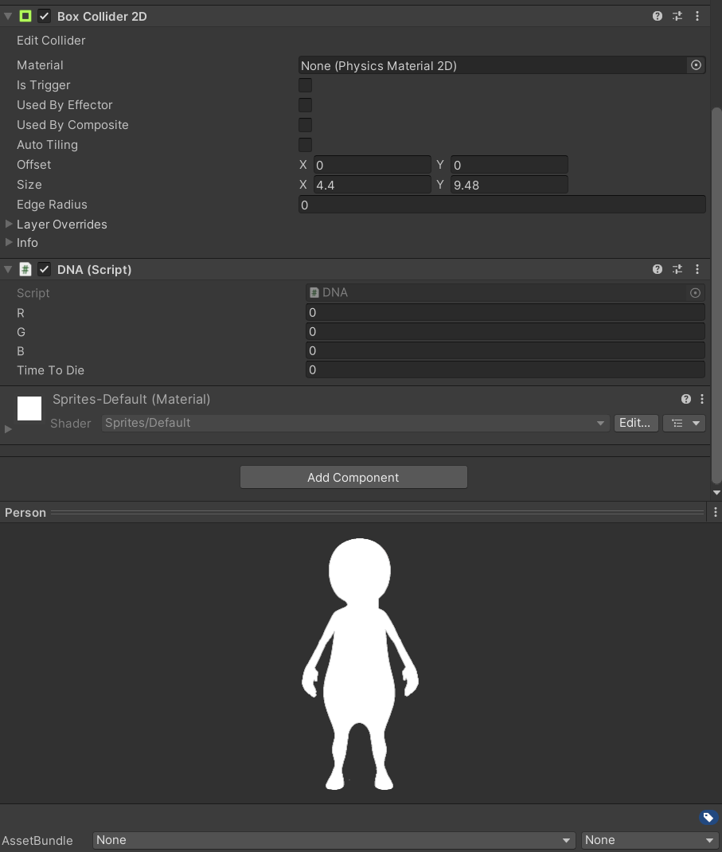

Casting our minds back to biology classes, remember that what we have is DNA and DNA is contained within a chromosome. It may make more sense to name this class Chromosome but, in any case, inside we have genes. And these genes responsible for passing along traits to our offspring. In this case, we want our people to pass values off to the offspring and that value will be associated with a colour, effectively passing off their colour to their offspring. So let us begin by storing the values for our people:



Since we are only dealing with three values, we probably have no need for an array. So, we keep them stored as public float.

Now we need to store whether a person has been clicked so that when a player is clicked on, we will say they have basically died:



Now, every time we click on a little person, they will be destroyed and therefore, the ones that live the longest on the screen are going to be the fittest in this game. These will then breed with each other to form our new population. So this Boolean value will set to true after we have clicked on them.

Let us create the code to control the timeToDie.We will store this as a public float so that we can access it from outside the script.



When they do die, we will record how long they lived so that we can then later sort them according their lifespan. Those that lived the longest lived are considered the fittest, and we can then proceed to breed them.

Now after this, we just need two more, I guess.

Just little helpers that we'll use in our code.

And this is access to the sprite renderer and the collider 2D.

And that's just so that we can turn them off when they've been clicked on in the start.

We then want to initialize our renderer and our collider values to point to the sprite renderer and

the collider 2D that is on this particular person, and that's so that we can use them when we click

on them.

So the code for clicking on something, let's put it up here.

We're just going to use an on mouse down, so no fancy raycasts or anything, just really simple way

to access when we've clicked on a collider and it looks like this.

So void on mouse down.

If you're not familiar with this, this is a unity owned method that you can use on a game object for

detecting when something with a collider has been clicked, when the user clicks on, the person dead

will become true.

And Time to Die is going to be set to the time elapsed in our population manager.

Now, we haven't created our population manager yet, so you will get an error when you try and save

this code, but just ignore that for now.

So what we're going to do is run the population for 10s and during that 10s you're going to be clicking

on the little people.

And when they die, it's going to record how long they lived for in that particular cycle.

And then we go to the next cycle or the next generation when we start the time again at zero and do

it again.

Now I've got a little debug in here.

This is just to check that you're clicking is working.

I probably just going to comment that out because I know it will work, but you can put that in there

and then we set our renderer and our collider to be disabled.

So just set them to both to be false so that you can't see that person because they're dead and you

can't click on them.

So get rid of their collider.

We still want the game object itself to exist in the hierarchy because we have to grab these guys and

breed them and we need access to their genes basically.

So that's important is turning them off, not destroying them.

All right.

So that you can save and don't forget, you will get an error.

Just ignore it, because that is all that you need in the DNA, in the hierarchy.

We're now going to add an empty game object.

This game object is going to manage our population for us.

So let's call it the population.

Manager.

And then we're going to create a script that goes on there and it will be called The Population Manager.

So C-sharp script.

Population manager.

Then drag and drop that onto the population manager in the hierarchy.

Okay, It's not going to let us because we've still got that error hanging over us because of the previous

code.

So we'll just have to go in and edit this.

So open it up and what we're going to do is add in a link to our game object prefab that we've got,

which is our little person.

So we want to public game object person prefab.

Like that.

And then we're going to set a population size because you can do this exercise with five, ten, 50,

100,000 little people if you want to.

Of course, anything like this with evolutionary computing, genetic algorithms and even neural network,

the bigger your population you're working with, the better outcomes you're going to get eventually.

Of course, this is a clicking game.

So if you're going to click a thousand people on the screen, it's not going to happen.

So we're just going to keep it small anyway, but we'll set it up to be a variable so you can change

it.

INT population size equals ten for now.

We also need to keep track of all of the people that we create, so I'll put a list up for that.

So let's call this a list of game objects.

And call it population and initialize it here.

New list.

Game object.

And we also need a timer in the environment that works out the elapsed time between them existing and

when we click on them.

So let's just create a public static float called Elapsed.

And this is the thing that's causing the error currently.

In the editor.

Once we've got that in there, this error we've got will go away and we will able to test it out.

Now, currently all we can do is really assign the person and once we've done that, we need to initialize

our game by creating the first population.

So there'll be ten of them and they'll all be person prefab.

We'll do that inside of Start.

So you want something that looks like this.

So this is a for loop.

It's going to loop around for population size number of times.

Okay.

So we're going to get ten loops out of this.

Each time we loop, we're going to work out a random position on the screen.

Now the screen is in X and Y because we're in 2D.

So the Z component in this case is just going to be zero.

And the range on the screen is from -9 to 9 in the X direction across here.

And from -4.5 to 4.5 in the Y direction, which is going up and down.

Now, I figured that out by putting something on the screen like my little person.

Let me show you that.

So if we just grab this little person, put them on the screen, there they are.

And then if we can find those over here.

Hit the W key and just move it like this.

And when you get to there, have a look at what its X position is.

So in this case -9.34 and I've put nine -nine inches the code, so that's all right.

And then go all the way to the other side to find the extreme in the x over there which you'll see as

positive nine and then you can do that for the Y direction.

Now lost my little person.

There it is.

And we can just go up there and then go down there and get those values for that range and then we'll

just delete.

All right.

So that's where these range values are coming from.

If you've got a different sized area on your screen that you're playing around with in the game view,

then by all means change this.

If you've got your camera at a different resolution, change it.

You might want to put 100 things on the screen.

This works for now with my particular settings.

Okay.

So once you've got this random for the person that you're creating at this time, we're going to create

the person.

So here we go.

We create a game object and we instantiate it from the prefab at the position and then we use a quaternion

dot identity.

This just gives us a zero rotational value default.

We do not want any rotations in this case.

We're just changing the position of that sprite on the screen.

Now, after we create our little person, we go ahead and set their DNA.

And remember their DNA has a red, green and a blue channel in it.

So we give them a random color value, basically.

And so RGB is between 0 and 1 for the colors where zero is none of that color.

And one indicates all of that color.

When it's 111, you've got white and when it's 000, you have black and everything else is in between.

Then once we've done that, we then add that new game object we've created to that list the population

so that we've got hold of it.

Okay, so you've done that, save it.

And then we're going to go back into unity and hopefully our error that we had before is going to disappear.

There it goes.

Select your population manager in the hierarchy.

Drag and drop that new script you just created onto the inspector.

And then for the person prefab that is exposed in the inspector, you want to drag your little person.

So grab your person prefab and drag and drop that into that exposed value there.

Now when we press play, we'll get ten people at random locations on the screen.

Now they're currently all white because we forgot to set the color up inside of the DNA script.

So just open up your DNA script again and go down to the start method here.

And that's where we need to use those color values that we've just set up through the population manager

and put them onto the renderer.

So go s renderer here.

Dot color equals new color.

Made up of R, G, and B, save that and we'll switch back to unity and we'll give it another whirl.

And this time we should get ten randomly located, multiple colored people, as you can see there.

Okay, so it's working well.

We should be able to click on them to actually, because we've already put that script in.

Okay, let's go back to our population manager and start adding in some code for breeding.

So the first thing we'll need at the top here is int trial time.

And this is how long we want each I guess little game trial to go for and let's go for 10s, which is

ample enough time to go around and click ten people and we're going to keep track of which generation

we're on as well.

So we'll store generation and we'll set it to one.

So the first population that we create that you see on the screen is generation number one.

Now the other thing that's really nice when you're doing this is to print out some stuff on the screen

so you can see what's going on.

Now I'm going to use on Gooey, which is our method I always use because it saves you setting up all

of the canvas stuff for something you're not going to continually use.

And here's just a simple on gooey.

It's going to first of all, I'm just setting up the font size and color so that you can see it in this

particular video using a gooey style which goes in the end of your gooey commands here.

So for these two labels, we're printing out generation plus whatever the generation value is, and

then the trial time followed by whatever elapsed is and elapsed is going to change based on the actual

time counter that we will put in.

So that's all done.

Let's now go down to the update where we will update our timer.

So add in this and what it's doing is it's increasing our elapsed value plus time delta time.

So it's just going to keep adding the time between frames which will show us on the screen the seconds

as they elapse.

Then if the elapsed time has become greater than the trial time, the trial is over.

So we've reached 10s.

Now what we're going to do is then run a new method called breed new population.

And this is where we will find out which of our members of the little people, tribe that have just

been created are the most fittest and we will breed them together.

Then we set elapsed time back to zero so we can start counting up to ten again.

So this is just going to keep cycling through ten second games essentially and continually breed the

population.

So we'll leave the code there for this lecture and we'll get stuck into the breed new population method

in the next part.